**Chess**

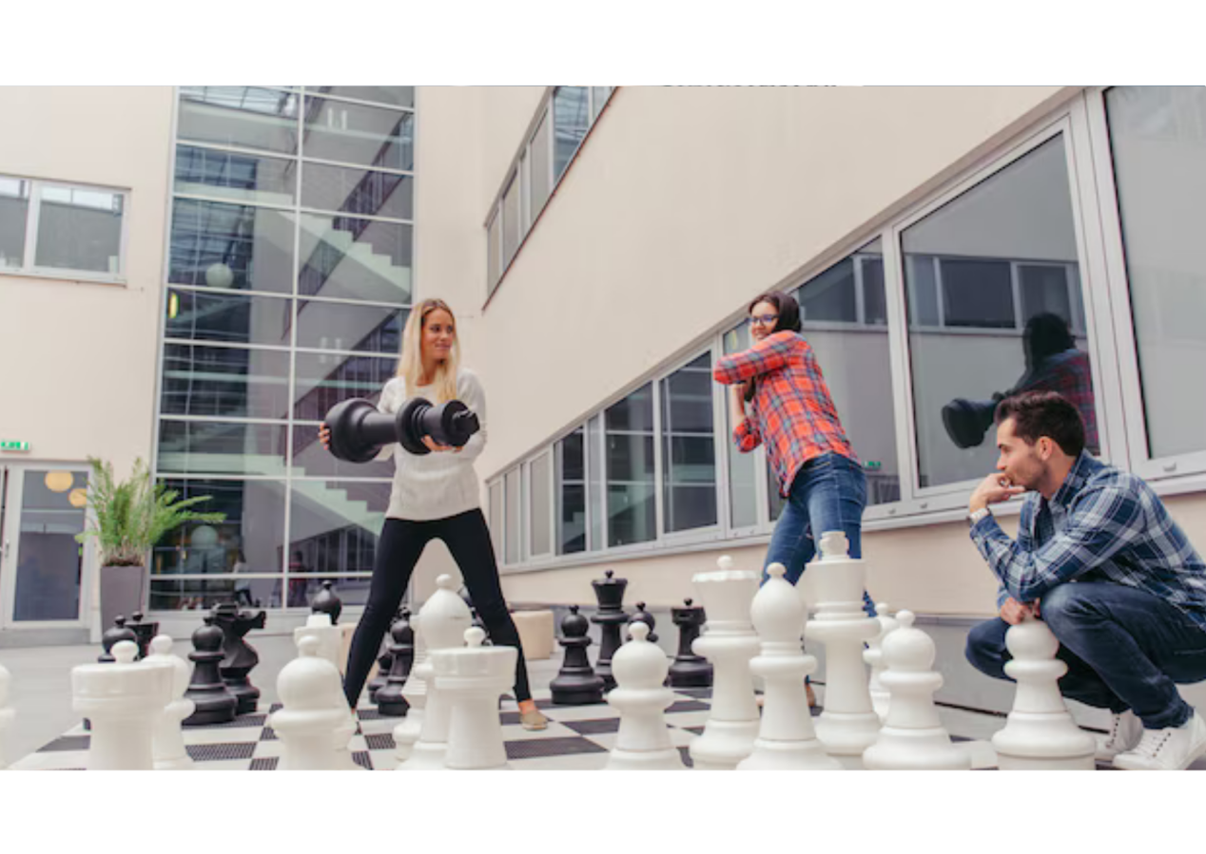

**Description:** A strategic board game where players move pieces on a square board with the objective to checkmate the opponent's king.

**How to Play:** Players take turns moving their pieces according to specific rules, aiming to capture the opponent's king.

**Location:** Indoor

**Things Needed:** Chessboard and pieces

**Number of Players:** 2